WinAVR이용해서 Arduino Uno C코딩 및 굽기(업로드)

WinAVR “Make all” 에러 해결

DLL update
C:\WinAVR-20100110\utils\bin 에 아래 DLL파일로 덮어 씀
http://www.madwizard.org/download/electronics/msys-1.0-vista64.zip

Tool – [WinAVR] Make all
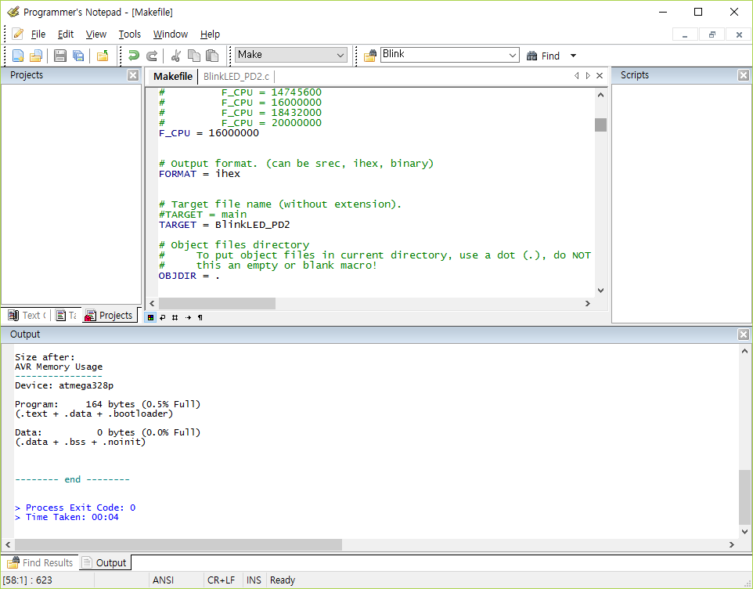

Tool – [WinAVR] Program
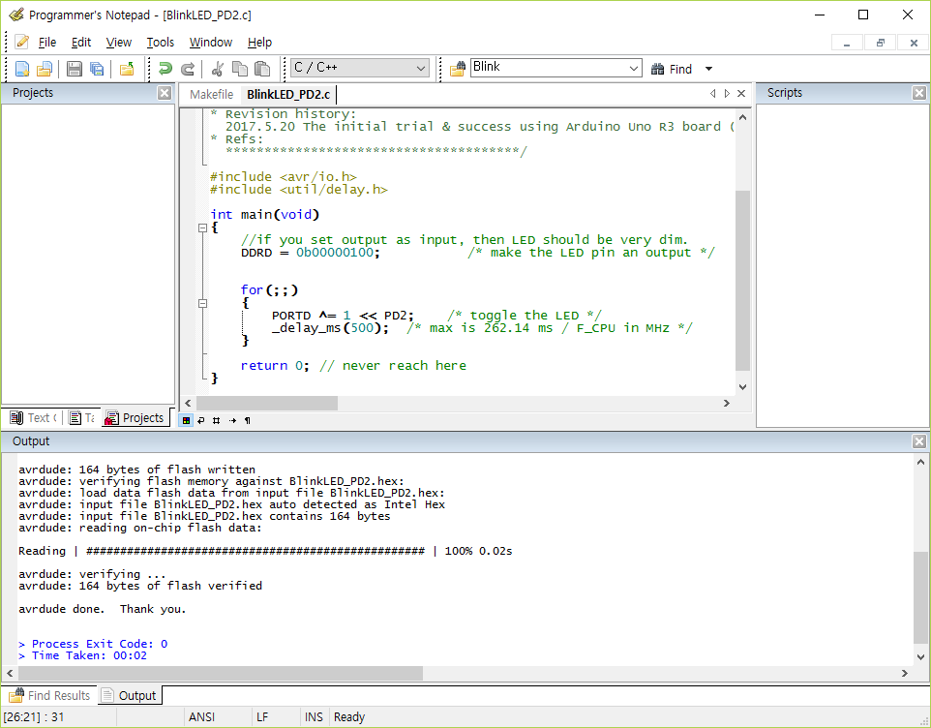

BlinkLED_PD2.c
/**************************************
* Target: Arduino Uno R3 16Mhz External Crystal
* Code Name: BlinkLED_PD2.c
* Author: Insoo Kim (insoo@hotmail.com)
* Created: 2017.5.20 (Sat)
* Updated: 2017.5.20
* Hex Size[Byte]: 164
* Desc: WinAVR as a professional Arduino development tool.
* Revision history:
2017.5.20 The initial trial & success using Arduino Uno R3 board (Made in China)
* Refs:
**************************************/

#include <avr/io.h>
#include <util/delay.h>

int main(void)
{
//if you set output as input, then LED should be very dim.
DDRD = 0b00000100; /* make the LED pin an output */

for(;;)
{
PORTD ^= 1 << PD2; /* toggle the LED */
_delay_ms(500); /* max is 262.14 ms / F_CPU in MHz */
}

return 0; // never reach here
}

Makefile
# Hey Emacs, this is a -*- makefile -*-
#----------------------------------------------------------------------------
# WinAVR Makefile Template written by Eric B. Weddington, J?rg Wunsch, et al.
#
# Released to the Public Domain
#
# Additional material for this makefile was written by:
# Peter Fleury
# Tim Henigan
# Colin O'Flynn
# Reiner Patommel
# Markus Pfaff
# Sander Pool
# Frederik Rouleau
# Carlos Lamas
#
#----------------------------------------------------------------------------
# On command line:
#
# make all = Make software.
#
# make clean = Clean out built project files.
#
# make coff = Convert ELF to AVR COFF.
#
# make extcoff = Convert ELF to AVR Extended COFF.
#
# make program = Download the hex file to the device, using avrdude.
# Please customize the avrdude settings below first!
#
# make debug = Start either simulavr or avarice as specified for debugging,
# with avr-gdb or avr-insight as the front end for debugging.
#
# make filename.s = Just compile filename.c into the assembler code only.
#
# make filename.i = Create a preprocessed source file for use in submitting
# bug reports to the GCC project.
#
# To rebuild project do "make clean" then "make all".
#----------------------------------------------------------------------------

# MCU name
MCU = atmega328p
#MCU = attiny13

# Processor frequency.
# This will define a symbol, F_CPU, in all source code files equal to the
# processor frequency. You can then use this symbol in your source code to
# calculate timings. Do NOT tack on a 'UL' at the end, this will be done
# automatically to create a 32-bit value in your source code.
# Typical values are:
# F_CPU = 1000000
# F_CPU = 1843200
# F_CPU = 2000000
# F_CPU = 3686400
# F_CPU = 4000000
# F_CPU = 7372800
# F_CPU = 8000000
# F_CPU = 11059200
# F_CPU = 14745600
# F_CPU = 16000000
# F_CPU = 18432000
# F_CPU = 20000000
F_CPU = 16000000

# Output format. (can be srec, ihex, binary)
FORMAT = ihex

# Target file name (without extension).
#TARGET = main
TARGET = BlinkLED_PD2

# Object files directory
# To put object files in current directory, use a dot (.), do NOT make
# this an empty or blank macro!
OBJDIR = .

# List C source files here. (C dependencies are automatically generated.)
#SRC = $(TARGET).c main.c
SRC = $(TARGET).c

# List C++ source files here. (C dependencies are automatically generated.)
CPPSRC =

# List Assembler source files here.
# Make them always end in a capital .S. Files ending in a lowercase .s
# will not be considered source files but generated files (assembler
# output from the compiler), and will be deleted upon "make clean"!
# Even though the DOS/Win* filesystem matches both .s and .S the same,
# it will preserve the spelling of the filenames, and gcc itself does
# care about how the name is spelled on its command-line.
ASRC =

# Optimization level, can be [0, 1, 2, 3, s].
# 0 = turn off optimization. s = optimize for size.
# (Note: 3 is not always the best optimization level. See avr-libc FAQ.)
OPT = s

# Debugging format.
# Native formats for AVR-GCC's -g are dwarf-2 [default] or stabs.
# AVR Studio 4.10 requires dwarf-2.
# AVR [Extended] COFF format requires stabs, plus an avr-objcopy run.
DEBUG = dwarf-2

# List any extra directories to look for include files here.
# Each directory must be seperated by a space.
# Use forward slashes for directory separators.
# For a directory that has spaces, enclose it in quotes.
EXTRAINCDIRS =

# Compiler flag to set the C Standard level.
# c89 = "ANSI" C
# gnu89 = c89 plus GCC extensions
# c99 = ISO C99 standard (not yet fully implemented)
# gnu99 = c99 plus GCC extensions
CSTANDARD = -std=gnu99

# Place -D or -U options here for C sources
CDEFS = -DF_CPU=$(F_CPU)UL

# Place -D or -U options here for ASM sources
ADEFS = -DF_CPU=$(F_CPU)

# Place -D or -U options here for C++ sources
CPPDEFS = -DF_CPU=$(F_CPU)UL
#CPPDEFS += -D__STDC_LIMIT_MACROS
#CPPDEFS += -D__STDC_CONSTANT_MACROS

#---------------- Compiler Options C ----------------
# -g*: generate debugging information
# -O*: optimization level
# -f...: tuning, see GCC manual and avr-libc documentation
# -Wall...: warning level
# -Wa,...: tell GCC to pass this to the assembler.
# -adhlns...: create assembler listing
CFLAGS = -g$(DEBUG)
CFLAGS += $(CDEFS)
CFLAGS += -O$(OPT)
CFLAGS += -funsigned-char
CFLAGS += -funsigned-bitfields
CFLAGS += -fpack-struct
CFLAGS += -fshort-enums
CFLAGS += -Wall
CFLAGS += -Wstrict-prototypes
#CFLAGS += -mshort-calls
#CFLAGS += -fno-unit-at-a-time
#CFLAGS += -Wundef
#CFLAGS += -Wunreachable-code
#CFLAGS += -Wsign-compare
CFLAGS += -Wa,-adhlns=$(<:%.c=$(OBJDIR)/%.lst)
CFLAGS += $(patsubst %,-I%,$(EXTRAINCDIRS))
CFLAGS += $(CSTANDARD)

#---------------- Compiler Options C++ ----------------
# -g*: generate debugging information
# -O*: optimization level
# -f...: tuning, see GCC manual and avr-libc documentation
# -Wall...: warning level
# -Wa,...: tell GCC to pass this to the assembler.
# -adhlns...: create assembler listing
CPPFLAGS = -g$(DEBUG)
CPPFLAGS += $(CPPDEFS)
CPPFLAGS += -O$(OPT)
CPPFLAGS += -funsigned-char
CPPFLAGS += -funsigned-bitfields
CPPFLAGS += -fpack-struct
CPPFLAGS += -fshort-enums
CPPFLAGS += -fno-exceptions
CPPFLAGS += -Wall
CPPFLAGS += -Wundef
#CPPFLAGS += -mshort-calls
#CPPFLAGS += -fno-unit-at-a-time
#CPPFLAGS += -Wstrict-prototypes
#CPPFLAGS += -Wunreachable-code
#CPPFLAGS += -Wsign-compare
CPPFLAGS += -Wa,-adhlns=$(<:%.cpp=$(OBJDIR)/%.lst)
CPPFLAGS += $(patsubst %,-I%,$(EXTRAINCDIRS))
#CPPFLAGS += $(CSTANDARD)

#---------------- Assembler Options ----------------
# -Wa,...: tell GCC to pass this to the assembler.
# -adhlns: create listing
# -gstabs: have the assembler create line number information; note that
# for use in COFF files, additional information about filenames
# and function names needs to be present in the assembler source
# files -- see avr-libc docs [FIXME: not yet described there]
# -listing-cont-lines: Sets the maximum number of continuation lines of hex
# dump that will be displayed for a given single line of source input.
ASFLAGS = $(ADEFS) -Wa,-adhlns=$(<:%.S=$(OBJDIR)/%.lst),-gstabs,--listing-cont-lines=100

#---------------- Library Options ----------------
# Minimalistic printf version
PRINTF_LIB_MIN = -Wl,-u,vfprintf -lprintf_min

# Floating point printf version (requires MATH_LIB = -lm below)
PRINTF_LIB_FLOAT = -Wl,-u,vfprintf -lprintf_flt

# If this is left blank, then it will use the Standard printf version.
PRINTF_LIB =
#PRINTF_LIB = $(PRINTF_LIB_MIN)
#PRINTF_LIB = $(PRINTF_LIB_FLOAT)

# Minimalistic scanf version
SCANF_LIB_MIN = -Wl,-u,vfscanf -lscanf_min

# Floating point + %[ scanf version (requires MATH_LIB = -lm below)
SCANF_LIB_FLOAT = -Wl,-u,vfscanf -lscanf_flt

# If this is left blank, then it will use the Standard scanf version.
SCANF_LIB =
#SCANF_LIB = $(SCANF_LIB_MIN)
#SCANF_LIB = $(SCANF_LIB_FLOAT)

MATH_LIB = -lm

# List any extra directories to look for libraries here.
# Each directory must be seperated by a space.
# Use forward slashes for directory separators.
# For a directory that has spaces, enclose it in quotes.
EXTRALIBDIRS =

#---------------- External Memory Options ----------------

# 64 KB of external RAM, starting after internal RAM (ATmega128!),
# used for variables (.data/.bss) and heap (malloc()).
#EXTMEMOPTS = -Wl,-Tdata=0x801100,--defsym=__heap_end=0x80ffff

# 64 KB of external RAM, starting after internal RAM (ATmega128!),
# only used for heap (malloc()).
#EXTMEMOPTS = -Wl,--section-start,.data=0x801100,--defsym=__heap_end=0x80ffff

EXTMEMOPTS =

#---------------- Linker Options ----------------
# -Wl,...: tell GCC to pass this to linker.
# -Map: create map file
# --cref: add cross reference to map file
LDFLAGS = -Wl,-Map=$(TARGET).map,--cref
LDFLAGS += $(EXTMEMOPTS)
LDFLAGS += $(patsubst %,-L%,$(EXTRALIBDIRS))
LDFLAGS += $(PRINTF_LIB) $(SCANF_LIB) $(MATH_LIB)
#LDFLAGS += -T linker_script.x

#---------------- Programming Options (avrdude) ----------------

# Programming hardware
# Type: avrdude -c ?
# to get a full listing.
#
AVRDUDE_PROGRAMMER = arduino
#AVRDUDE_PROGRAMMER = usbtiny

# com1 = serial port. Use lpt1 to connect to parallel port.
#AVRDUDE_PORT = usb # programmer connected to serial device
AVRDUDE_PORT = com10 # programmer connected to serial device (depends on Win device driver)

AVRDUDE_WRITE_FLASH = -U flash:w:$(TARGET).hex
#AVRDUDE_WRITE_EEPROM = -U eeprom:w:$(TARGET).eep

# Uncomment the following if you want avrdude's erase cycle counter.
# Note that this counter needs to be initialized first using -Yn,
# see avrdude manual.
#AVRDUDE_ERASE_COUNTER = -y

# Uncomment the following if you do /not/ wish a verification to be
# performed after programming the device.
#AVRDUDE_NO_VERIFY = -V

# Increase verbosity level. Please use this when submitting bug
# reports about avrdude. See <http://savannah.nongnu.org/projects/avrdude>
# to submit bug reports.
#AVRDUDE_VERBOSE = -v -v

AVRDUDE_FLAGS = -p $(MCU) -P $(AVRDUDE_PORT) -c $(AVRDUDE_PROGRAMMER)
AVRDUDE_FLAGS += $(AVRDUDE_NO_VERIFY)
AVRDUDE_FLAGS += $(AVRDUDE_VERBOSE)
AVRDUDE_FLAGS += $(AVRDUDE_ERASE_COUNTER)

#---------------- Debugging Options ----------------

# For simulavr only - target MCU frequency.
DEBUG_MFREQ = $(F_CPU)

# Set the DEBUG_UI to either gdb or insight.
# DEBUG_UI = gdb
DEBUG_UI = insight

# Set the debugging back-end to either avarice, simulavr.
DEBUG_BACKEND = avarice
#DEBUG_BACKEND = simulavr

# GDB Init Filename.
GDBINIT_FILE = __avr_gdbinit

# When using avarice settings for the JTAG
JTAG_DEV = /dev/com1

# Debugging port used to communicate between GDB / avarice / simulavr.
DEBUG_PORT = 4242

# Debugging host used to communicate between GDB / avarice / simulavr, normally
# just set to localhost unless doing some sort of crazy debugging when
# avarice is running on a different computer.
DEBUG_HOST = localhost

#============================================================================

# Define programs and commands.
SHELL = sh
CC = avr-gcc
OBJCOPY = avr-objcopy
OBJDUMP = avr-objdump
SIZE = avr-size
AR = avr-ar rcs
NM = avr-nm
AVRDUDE = avrdude
REMOVE = rm -f
REMOVEDIR = rm -rf
COPY = cp
WINSHELL = cmd

# Define Messages
# English
MSG_ERRORS_NONE = Errors: none
MSG_BEGIN = -------- begin --------
MSG_END = -------- end --------
MSG_SIZE_BEFORE = Size before:
MSG_SIZE_AFTER = Size after:
MSG_COFF = Converting to AVR COFF:
MSG_EXTENDED_COFF = Converting to AVR Extended COFF:
MSG_FLASH = Creating load file for Flash:
MSG_EEPROM = Creating load file for EEPROM:
MSG_EXTENDED_LISTING = Creating Extended Listing:
MSG_SYMBOL_TABLE = Creating Symbol Table:
MSG_LINKING = Linking:
MSG_COMPILING = Compiling C:
MSG_COMPILING_CPP = Compiling C++:
MSG_ASSEMBLING = Assembling:
MSG_CLEANING = Cleaning project:
MSG_CREATING_LIBRARY = Creating library:

# Define all object files.
OBJ = $(SRC:%.c=$(OBJDIR)/%.o) $(CPPSRC:%.cpp=$(OBJDIR)/%.o) $(ASRC:%.S=$(OBJDIR)/%.o)

# Define all listing files.
LST = $(SRC:%.c=$(OBJDIR)/%.lst) $(CPPSRC:%.cpp=$(OBJDIR)/%.lst) $(ASRC:%.S=$(OBJDIR)/%.lst)

# Compiler flags to generate dependency files.
GENDEPFLAGS = -MMD -MP -MF .dep/$(@F).d

# Combine all necessary flags and optional flags.
# Add target processor to flags.
ALL_CFLAGS = -mmcu=$(MCU) -I. $(CFLAGS) $(GENDEPFLAGS)
ALL_CPPFLAGS = -mmcu=$(MCU) -I. -x c++ $(CPPFLAGS) $(GENDEPFLAGS)
ALL_ASFLAGS = -mmcu=$(MCU) -I. -x assembler-with-cpp $(ASFLAGS)

# Default target.
all: begin gccversion sizebefore build sizeafter end

# Change the build target to build a HEX file or a library.
build: elf hex eep lss sym
#build: lib

elf: $(TARGET).elf
hex: $(TARGET).hex
eep: $(TARGET).eep
lss: $(TARGET).lss
sym: $(TARGET).sym
LIBNAME=lib$(TARGET).a
lib: $(LIBNAME)

# Eye candy.
# AVR Studio 3.x does not check make's exit code but relies on
# the following magic strings to be generated by the compile job.
begin:
@echo
@echo $(MSG_BEGIN)

end:
@echo $(MSG_END)
@echo

# Display size of file.
HEXSIZE = $(SIZE) --target=$(FORMAT) $(TARGET).hex
ELFSIZE = $(SIZE) --mcu=$(MCU) --format=avr $(TARGET).elf

sizebefore:
@if test -f $(TARGET).elf; then echo; echo $(MSG_SIZE_BEFORE); $(ELFSIZE); \
2>/dev/null; echo; fi

sizeafter:
@if test -f $(TARGET).elf; then echo; echo $(MSG_SIZE_AFTER); $(ELFSIZE); \
2>/dev/null; echo; fi

# Display compiler version information.
gccversion :
@$(CC) --version

# Program the device.
program: $(TARGET).hex $(TARGET).eep
$(AVRDUDE) $(AVRDUDE_FLAGS) $(AVRDUDE_WRITE_FLASH) $(AVRDUDE_WRITE_EEPROM)

# Generate avr-gdb config/init file which does the following:
# define the reset signal, load the target file, connect to target, and set
# a breakpoint at main().
gdb-config:
@$(REMOVE) $(GDBINIT_FILE)
@echo define reset >> $(GDBINIT_FILE)
@echo SIGNAL SIGHUP >> $(GDBINIT_FILE)
@echo end >> $(GDBINIT_FILE)
@echo file $(TARGET).elf >> $(GDBINIT_FILE)
@echo target remote $(DEBUG_HOST):$(DEBUG_PORT) >> $(GDBINIT_FILE)
ifeq ($(DEBUG_BACKEND),simulavr)
@echo load >> $(GDBINIT_FILE)
endif
@echo break main >> $(GDBINIT_FILE)

debug: gdb-config $(TARGET).elf
ifeq ($(DEBUG_BACKEND), avarice)
@echo Starting AVaRICE - Press enter when "waiting to connect" message displays.
@$(WINSHELL) /c start avarice --jtag $(JTAG_DEV) --erase --program --file \
$(TARGET).elf $(DEBUG_HOST):$(DEBUG_PORT)
@$(WINSHELL) /c pause

else
@$(WINSHELL) /c start simulavr --gdbserver --device $(MCU) --clock-freq \
$(DEBUG_MFREQ) --port $(DEBUG_PORT)
endif
@$(WINSHELL) /c start avr-$(DEBUG_UI) --command=$(GDBINIT_FILE)

# Convert ELF to COFF for use in debugging / simulating in AVR Studio or VMLAB.
COFFCONVERT = $(OBJCOPY) --debugging
COFFCONVERT += --change-section-address .data-0x800000
COFFCONVERT += --change-section-address .bss-0x800000
COFFCONVERT += --change-section-address .noinit-0x800000
COFFCONVERT += --change-section-address .eeprom-0x810000

coff: $(TARGET).elf
@echo
@echo $(MSG_COFF) $(TARGET).cof
$(COFFCONVERT) -O coff-avr $< $(TARGET).cof

extcoff: $(TARGET).elf
@echo
@echo $(MSG_EXTENDED_COFF) $(TARGET).cof
$(COFFCONVERT) -O coff-ext-avr $< $(TARGET).cof

# Create final output files (.hex, .eep) from ELF output file.
%.hex: %.elf
@echo
@echo $(MSG_FLASH) $@
$(OBJCOPY) -O $(FORMAT) -R .eeprom -R .fuse -R .lock $< $@

%.eep: %.elf
@echo
@echo $(MSG_EEPROM) $@
-$(OBJCOPY) -j .eeprom --set-section-flags=.eeprom="alloc,load" \
--change-section-lma .eeprom=0 --no-change-warnings -O $(FORMAT) $< $@ || exit 0

# Create extended listing file from ELF output file.
%.lss: %.elf
@echo
@echo $(MSG_EXTENDED_LISTING) $@
$(OBJDUMP) -h -S -z $< > $@

# Create a symbol table from ELF output file.
%.sym: %.elf
@echo
@echo $(MSG_SYMBOL_TABLE) $@
$(NM) -n $< > $@

# Create library from object files.
.SECONDARY : $(TARGET).a
.PRECIOUS : $(OBJ)
%.a: $(OBJ)
@echo
@echo $(MSG_CREATING_LIBRARY) $@
$(AR) $@ $(OBJ)

# Link: create ELF output file from object files.
.SECONDARY : $(TARGET).elf
.PRECIOUS : $(OBJ)
%.elf: $(OBJ)
@echo
@echo $(MSG_LINKING) $@
$(CC) $(ALL_CFLAGS) $^ --output $@ $(LDFLAGS)

# Compile: create object files from C source files.
$(OBJDIR)/%.o : %.c
@echo
@echo $(MSG_COMPILING) $<
$(CC) -c $(ALL_CFLAGS) $< -o $@

# Compile: create object files from C++ source files.
$(OBJDIR)/%.o : %.cpp
@echo
@echo $(MSG_COMPILING_CPP) $<
$(CC) -c $(ALL_CPPFLAGS) $< -o $@

# Compile: create assembler files from C source files.
%.s : %.c
$(CC) -S $(ALL_CFLAGS) $< -o $@

# Compile: create assembler files from C++ source files.
%.s : %.cpp
$(CC) -S $(ALL_CPPFLAGS) $< -o $@

# Assemble: create object files from assembler source files.
$(OBJDIR)/%.o : %.S
@echo
@echo $(MSG_ASSEMBLING) $<
$(CC) -c $(ALL_ASFLAGS) $< -o $@

# Create preprocessed source for use in sending a bug report.
%.i : %.c
$(CC) -E -mmcu=$(MCU) -I. $(CFLAGS) $< -o $@

# Target: clean project.
clean: begin clean_list end

clean_list :
@echo
@echo $(MSG_CLEANING)
$(REMOVE) $(TARGET).hex
$(REMOVE) $(TARGET).eep
$(REMOVE) $(TARGET).cof
$(REMOVE) $(TARGET).elf
$(REMOVE) $(TARGET).map
$(REMOVE) $(TARGET).sym
$(REMOVE) $(TARGET).lss
$(REMOVE) $(SRC:%.c=$(OBJDIR)/%.o)
$(REMOVE) $(SRC:%.c=$(OBJDIR)/%.lst)
$(REMOVE) $(SRC:.c=.s)
$(REMOVE) $(SRC:.c=.d)
$(REMOVE) $(SRC:.c=.i)
$(REMOVEDIR) .dep

# Create object files directory
$(shell mkdir $(OBJDIR) 2>/dev/null)

# Include the dependency files.
-include $(shell mkdir .dep 2>/dev/null) $(wildcard .dep/*)

# Listing of phony targets.
.PHONY : all begin finish end sizebefore sizeafter gccversion \
build elf hex eep lss sym coff extcoff \
clean clean_list program debug gdb-config

참조
http://www.avrfreaks.net/forum/windows-81-compilation-error?page=all

